**VISVESVARAYA TECHNOLOGICAL UNIVERSITY**

**BELAGAVI , KARNATAKA**



**INTERNSHIP TRAINING REPORT**

**ON**

**MANUFACTURING AND EVALUATION OF TABLETS**

 A report submitted in the partial fulfillment of the requirements for the award of degree of

**BACHELOR OF ENGINEERING**

**IN**

**BIOTECHNOLOGY**

 SUBMITTED BY:

                              NANCY YADAV (1SG18BT026)

NISHA K (1SG18BT030)

SUMA K (1SG18BT046)



**SAPTHAGIRI COLLEGE OF ENGINEERING**

(Affiliated to VTU, Belagavi, Approved by AICTE, New Delhi 2021-2022**)**

**2021-2022**

**SAPTHAGIRI COLLEGE OF ENGINEERING**

**BENGALURU-560057**

         (Affiliated to Visvesvaraya Technological University, Belagavi, Karnataka)



**DEPARTMENT OF BIOTECHNOLOGY**

***CERTIFICATE***

 Certified that the Internship report entitled “**MANUFACTURING AND EVALAUATION OF TABLETS**”carried out by **NANCY YADAV (1SG18BT026), NISHA K (1SG18BT030), SUMA K (1SG18BT046)** bonafide students of Eighthsemester,**Department of Biotechnology**, Sapthagiri College of Engineering, Bengaluru in partial fulfillment of the award of the **Bachelor of Engineering in Biotechnology** of the **Visvesvaraya Technological University,** Belagaviduring the academic year **2021-2022**. It is certified that all corrections/suggestionsindicated for Internal assessment have been incorporated in the report depositedin the departmental library. The Internship report has been approved as it satisfies the academic requirements in respect of Internship report prescribed for the said degree.

Dr. Veena S More Dr. H Ramakrishna

Under the Guidance Head of the Department Principal

Certificate

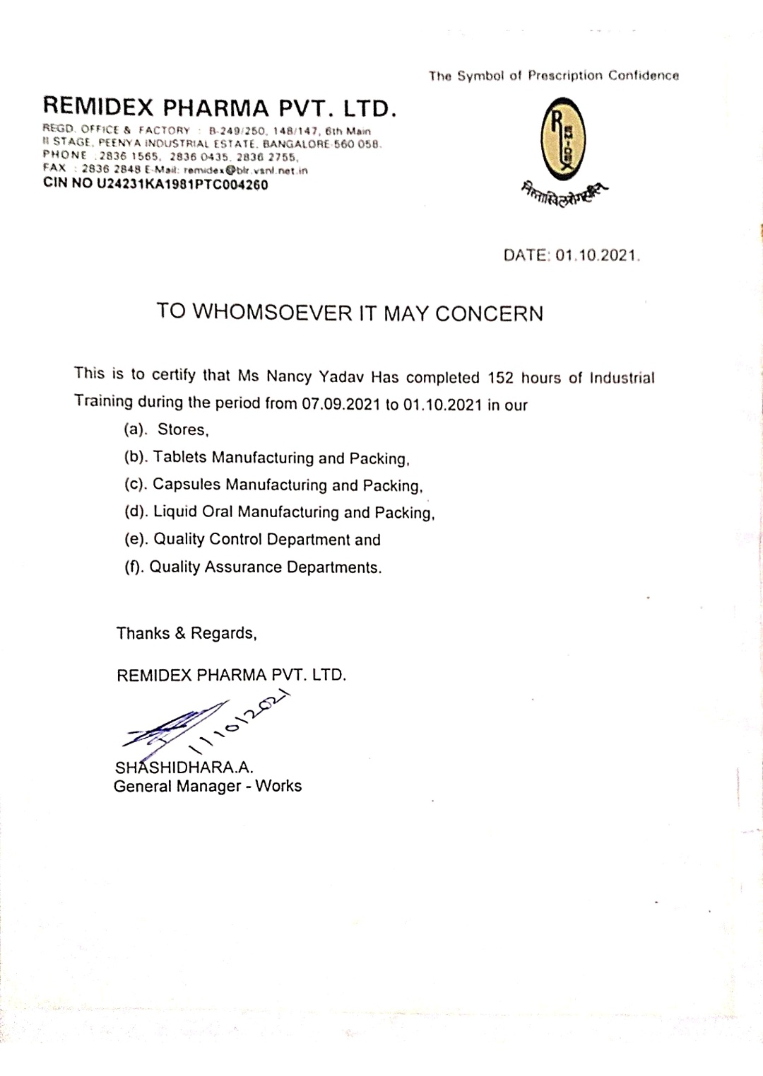

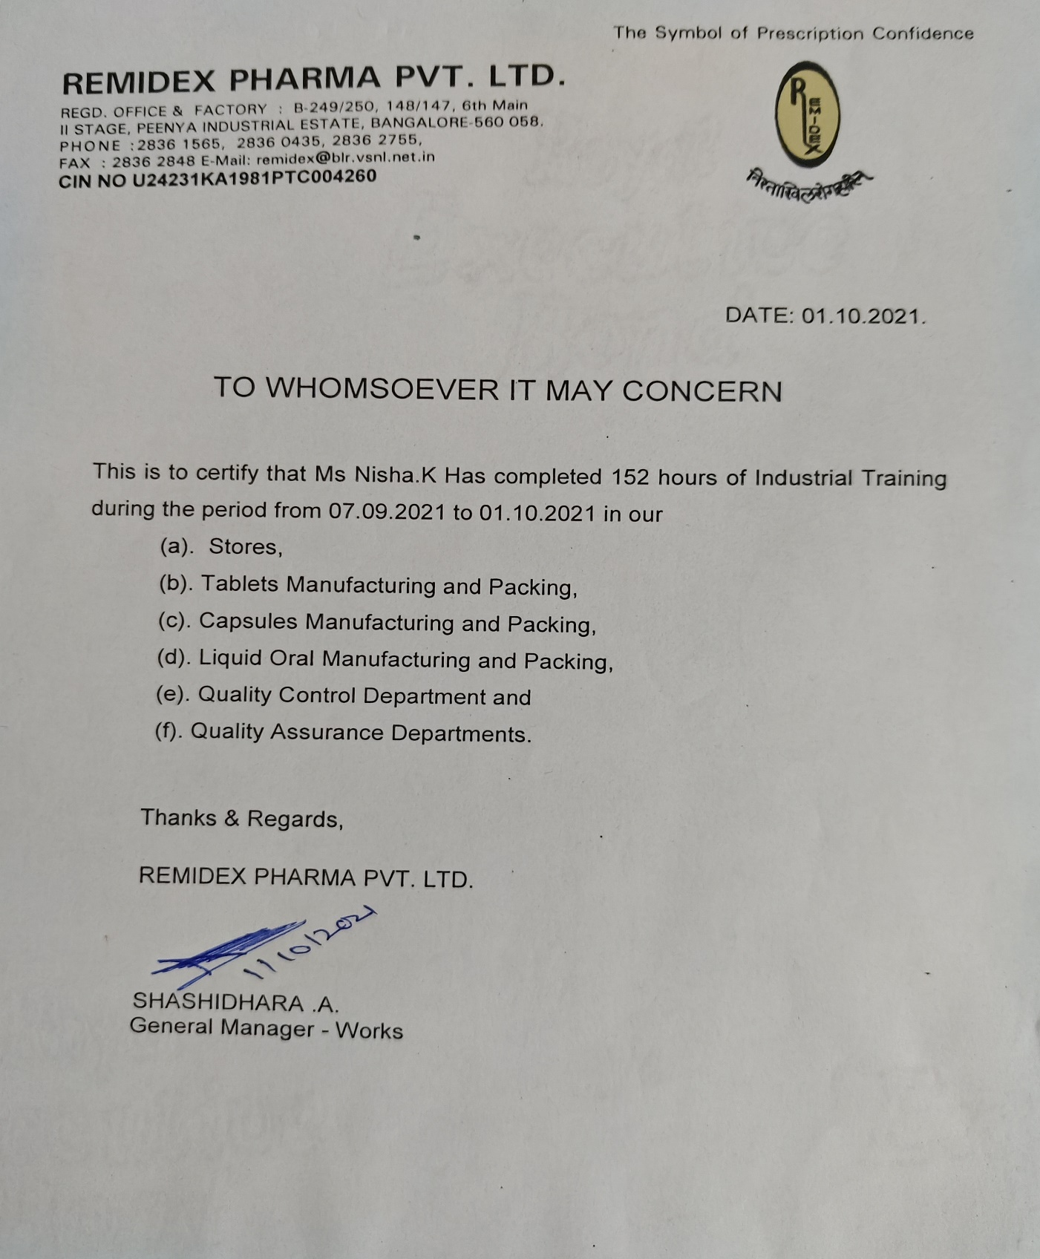

**acceptance letter**

Abstract

Pharmaceutical oral dosage forms have been used widely for mainly due to their convenience of administration and their suitability for delivery of drugs for systematic effects the tablets can be made directly from powders or from granules pellets, or from film-coated multiple units. A process improvement in a tablet manufacturing process within a pharmaceutical industry was carried out based on an eco-efficiency approach. As it is one of the most energy consuming processes in the production line, the tablet manufacturing process was considered. It has the highest production volume with a complicated and long manufacturing product life cycle. Tablets are now the most popular dosage forms, accounting for some 70% of all ethical pharmaceutical preparations produced. Tablet is most widely used because of its stability and patient acceptability. Tablet is defined as solid pharmaceutical dosage form containing drug substance generally with suitable diluents and prepared by either compression or moulding methods. Tablets remain popular as a dosage form because of the advantages afforded, both to the manufacturer (e.g. simplicity and economy of the preparation, stability, and convenience in packing, shipping and dispensing) and the patient. Because of their composition, method of manufacture or intended use, tablets present a variety of characteristics and consequently there are several categories of tablets. Tablet formulation and design may be described as the process where by the formulator ensures that the correct amount of the drug in the right form is delivered at or over the proper time at the proper rate and in the desired location, while having its chemical integrity protected to that point. Latest concepts and regulations focus on bioavailability, bioequivalence and validation etc. impact formulation designing and manufacture. Among all available dosage form, tablet is most widely used because of its stability and patient acceptability. The better aesthetic quality like color, texture, mouth feel, and taste masking depended on film and sugar coatings, so the coating is an important part in the manufacturing of the tablet. Film and sugar coatings have the number of disadvantages.

**TABLE OF CONTENTS**

|  |  |  |
| --- | --- | --- |
| **SL NO** | **CONTENTS** | **PAGE NO** |
| 1. | Certificate  Acceptance letter  Abstract  Company profile | 6 |
| 2. | Introduction | 12 |
| 3. | Raw materials | 13 |
| 4. | Manufacturing unit | 16 |
| 5. | Quality control | 30 |
| 6. | Quality assurance | 31 |
| 7. | Conclusion | 40 |

List of figures

|  |  |  |
| --- | --- | --- |
| Sl No | Figure Discription | Page No |
|  | Remidex Pharma Pvt. Ltd. | 11 |
|  | Storage Area, Approved Label | 12 |
|  | Dispensing Both | 20 |
|  | Rapid mixer granulation, Fluid batch dryer,  Octagonal blending, Compression | 21 |
|  | Weighing machine | 23 |
|  | Disintegration test | 24 |
|  | Dissolution, Hardness tester | 25 |
|  | Friability Test | 26 |
|  | Standard coating machine | 28 |
|  | Perforated coating machine | 30 |
|  | UV Spectroscopy | 33 |
|  | Dissolution tester, pH meter | 34 |
|  | Stability Chamber, Cooling chamber and deep  freezer | 35 |
|  | HPLC | 36 |
|  | Horizontal autoclave, Laminar airflow | 37 |
|  | Storage area | 15 |

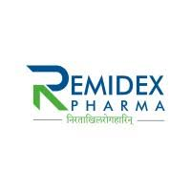**Company Profile**

Remidex Pharma Private Limited is an unlisted private company incorporated on 15 June, 1981. It is classified as a private limited company and is located in Bangalore, Karnataka. Its authorized share capital is INR 3.00 crore and the total paid-up capital is INR 2.50 crore.

The current status of Remidex Pharma Private Limited is - Active.

The last reported AGM (Annual General Meeting) of Remidex Pharma Private Limited, per our records, was held on 31 December, 2020. Also, as per our records, its last balance sheet was prepared for the period ending on 31 March, 2020.

Remidex Pharma Private Limited has three directors - Nilima Dayanand Rao, Nandan Pejavar Rao, and others.

The Corporate Identification Number (CIN) of Remidex Pharma Private Limited is U24231KA1981PTC004260. The registered office of Remidex Pharma Private Limited is at B-249/250, II STAGE, PEENYA INDUSTRIAL AREA, BANGALORE, INDUSTRIAL AREA, BANGALORE, Karnataka.

**VISION**

To be the sole leader in the development and manufacturing processes in the pharmaceutical industry. To extend the borders of the company across the globe. To dedicate to the medicine of the highest standard and market it at the affordable prices that reach the people in a easy manner.

**Introduction**

The pharmaceutical industry is an important component of health care system throughout the world; it is comprised of many public and private organization that perform the scientific research to discover, develop, new drugs, manufacture and market medicines for human health. It is mainly based on research and development (R& D) works that help in treatment and research. Pharmaceuticals have grown to be a significant section of health care because of their humongous factor towards betterment of open public health. They have helped to improve life time by treating conditions that were otherwise incurable.

Remidex Pharma Pvt.Ltd. Bangalore mainly deals with the manufacturing of tablets. All the process are based on R&D works which are followed systematically in each unit. There are professionals guiding in each unit to achieve the best outcomes which enhances the standard of the company. Every unit follows the Standard Operating Procedures [SOP’s]. It produces the finest quality products to the markets.

The company comprises of SIX units

1. Raw materials
2. Manufacturing unit
3. Quality Assurance
4. Quality Control
5. Packing unit
6. Storage.

1. Raw Materials

The pharmaceutical industry faces a lot of constraints and has different specialties, making it stand completely on a different scale than any other industry types. Pharma industry needs extreme precision and care in each step ranging from collecting the pharma raw materials to get in hand the ready product for the supply.

Pharmaceutical Raw Materials can be categorized into the following three categories:

1.1. Active Pharmaceutical Ingredients (APIs)

1.2. Inactive Ingredients or Excipients

1.3. Packaging Raw Materials

1.1. Active Pharmaceutical Ingredients (APIs)

API is one of the main parts of the pharma drug which is pharmaceutically active and is responsible for the drug action. Accuracy and Precision with the raw materials are two main must aspects for while making API. Strengths of APIs: There are certain standards to determine APIs strength in each drug. Manufacturers are required by the FDA to prove their products potency in labs as well as in real life through patients.

1.2.PHARMACEUTICAL RAW MATERIALS OF EXCIPIENTS

Excipients also called as inactive ingredients or drug carriers. Pharma raw materials used as excipients consist of solvents and other such carriers. Excipients bring bulkiness and stability in the drug formulation, along with facilitating absorption and preventing denaturation of drugs. There are guidelines by international pharmaceutical standards for the materials to get qualified as an excipient.

* 1. PHARMACEUTICAL RAW MATERIALS OF PACKAGING

Packaging in the pharmaceutical industry also need to be perfect and precise. Raw materials used for packaging in the pharmaceutical industry includes plastics, polymer, glass, aluminium foil, paper and more. Packaging is made a separate category for the pharma because of the use of diversified raw materials.

Raw material testing is crucially important for ensuring safety, quality and efficacy of pharmaceutical products.

Given below is a list of some of the most common test that were carried out in the industry for pharmaceutical raw materials –

• Assay

• Impurities and Related Substances

• Residual Solvents and Organic Volatile Impurities

• Identification tests by FTIR, chemical analysis et cetera

• Limit tests for heavy metals by chemical methods or by ICP or ICP MS

• Microbial limit tests

• Sterility testing

• Microbiological assays

• Particle size distribution by optical microscopy

• Melting point

• Differential scanning calorimetry (DSC)

Procedures of movement of raw materials

PROCEDURE

* After receiving the materials, store person shall unload the materials in storage area and clean the material with a dry line-free cloth and transfer the materials in designated quarantined area after physical verification and affix quarantine label
* Store person shall record his observation in a physical verification record
* When the material is released by QC, QC person shall affix “APPROVED” label on each container and store person shall transfer the materials in the designated approved storage area as per their storage condition

STORAGE OF RAW MATERIAL

* If raw material storage limit is 2℃ to 8℃, transfer the materials in cold storage and the daily record is maintained
* If material storage limit is below 25℃ transfer the material in RM
* If the material storage condition is not specified store the material in RM store
* If material is rejected by QC department, it must be shifted to the REJECTED storage area under lock and key. A book of rejected material in this area is to be maintained
* Information of rejection of the materials should be given to purchasing department
* After dispensing the loose quantity of the material should be closed tightly with nylon thread and shifts it into original container
* In case temperature of stores exceeds the limit information to maintanence for rectification
* Rejected raw material shall be sent back to supplier as per the instructions are given by purchasing department
* If the rejected material is destroyed in factory premises, prepare the destruction note and follow the SOP.

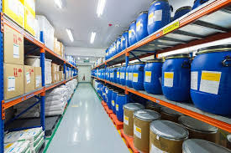

Storage area Approved label

1. Manufacturing Unit

Tablets are commonly manufactured by wet granulation, dry granulation or direct compression .These methods may be considered to consist of a series of steps weighing ,milling, granulation, drying ,compression , coating and packing.

Primary goals for tablet manufacturing process

* To formulate the tablets that are hard and strong to withstand the mechanical shock encountered during manufacturing, packing, shipping, dispensing and use.
* To formulate the tablet that are uniform in weight and drug content.
* To formulate the tablet that are physically and chemically stable over a long period of time
* To formulate the tablet that have elegant product identity which is free from any tablet defect

Procedure for manufacturing tablet

* Dispensing (weighing and measuring)
* Dispensing is the first step in any pharmaceutical manufacturing process.
* Dispensing is one of the critical steps in pharmaceutical manufacturing; as during this step, the weight of each ingredient in the mixture is determined according to dose.
* Dispensing may be done by purely manual by hand scooping from primary containers and weighing each ingredient by hand on a weigh scale, manual weighing with material lifting assistance like Vacuum transfer and Bag lifters, manual or assisted transfer with automated weighing on weigh table, manual or assisted filling of loss-in weight dispensing system, automated dispensaries with mechanical devices such as vaccum loading system and screw feed system.
* Issues like weighing accuracy, dust control laminar air flow booths, glove boxes), during manual handling, lott control of each ingredient, material movement into and out of dispensary should be considered during dispensing.
* Sizing
* The sizing (size reduction, milling, crushing, grinding, pulverization) is an impotent step involved in the tablet manufacturing.
* In manufacturing of compressed tablet, the mixing or blending of several solid ingredients of pharmaceuticals is easier and more uniform if the ingredients are approximately of same size.
* This provides a greater uniformity of dose. A fine particle size is essential in case of lubricant mixing with granules for its proper function.

Advantages associated with size reduction in tablet manufacture are as follows:

1. It increases surface area, which may enhance an active ingredient’s dissolution rate and hence bioavailability.
2. Improved the tablet-to-tablet content uniformity by virtue of the increased number of particles per unit weigh
3. Controlled particle size distribution of dry granulation or mix to promote better flow of texture in tablet machine
4. Improved flow properties of raw materials
5. Improved colour and/or active ingredient dispersion in tablet excipients.
6. Uniformly sized wet granulation to promote uniform drying.
7. There are also certain disadvantages associated with this unit operation if not controlled properly

Powder blending

* The successful mixing of powder is acknowledged to be more difficult unit operation because, unlike the situation with liquid, perfect homogeneity is practically unattainable.
* In practice, problems also arise because of the inherent cohesiveness and resistance to movement between the individual particles.
* The process is further complicated in many system, by the presence of substantial segregation influencing the powder mix.
* They arise because of difference in size, shape, and density of the component particles.
* The powder/granules blending are involved at stage of pre

granulation and/or post granulation stage of tablet manufacturing.

* Each process of mixing has optimum mixing time and so prolonged mixing may result in an undesired product.
* So, the optimum mixing time and mixing speed are to be evaluated. Blending step prior to compression is normally achieved in a simple tumble blender.
* The Blender may be a fixed blender into which the powders are charged, blended and discharged.
* It is now common to use a bin blender which blends.
* In special cases of mixing a lubricant, over mixing should be particularly monitered.
* But now a day to optimize the manufacturing process particularly in wet granulation the various improved equipments which combines several of processing steps (mixing, granulation and/or drying) are used.
* They are “Mixer granulator” or “High shear mixing machine”.
* The powder/granules blending are involved at stage of pre granulation and/or post granulation stage of tablet manufacturing.
* Each process of mixing has optimum mixing time and so prolonged mixing may result in an undesired product.
* So, the optimum mixing time and mixing speed are to be evaluated.
* Blending step prior to compression is normally achieved in a simple tumble blender.

Granulation

* Following particle size reduction and blending, the formulation may be granulated, which provides homogeneity of drug distribution in blend.
* The granulation process combines one or more powder particles and forms a granule that will allow tableting to be within required limits
* It is the process of collecting particles together by creating bonds between them. Bonds are formed by compression or by using a binding agent.
* Granulation is extensively used in the pharmaceutical industry, for manufacturing of tablets and pellets.
* This way predictable and repeatable process is possible and granules of consistent quality can be produced.
* Granulation is carried out for various reasons, one of which is to prevent the segregation of the constituents of powder mix. Segregation is due to differences in the size or density of the components of the mix. Normally, the smaller and/or denser particles tend to concentrate at the base of the container with the larger and/or less dense ones on the top.
* An ideal granulation will contain all the constituents of the mix in the correct proportion in each granule and segregation of granules will not occur.
* Many powders, because of their small size, irregular shape or surface characteristics, are cohesive and do not flow well.
* Granules produced from such a cohesive system will be larger and more isodiametric (roughly spherical), both factors contributing to improved flow properties.
* Some powders are difficult to compact even if a readily compactable adhesive is included in the mix, but granules of the same powders are often more easily compacted. This is associated with the distribution of the adhesive within the granule and is a function of the method employed to produce the granule.
* Powdered sugar’s small particles have poor flow and compression characteristics. These small particles would have to be compressed very slowly for a long period of time to make a worthwhile tablet.
* Unless the powdered sugar is granulated, it could not efficiently be made into a tablet that has good tablet characteristics such as uniform content or consistent hardness.
* Two types of granulation technologies are employed: wet granulation and dry granulation.

In this industry they followed wet granulation process

Wet granulation

* In wet granulation, granules are formed by the addition of a granulation liquid onto a powder bed which is under the influence of an impeller, screws . The agitation resulting in the system along with the wetting of the components within the formulation results in the aggregation of the primary powder particles to produce wet granules
* The granulation liquid (fluid) contains a solvent or carrier material which must be volatile so that it can be removed by drying, and depending on the intended application, be non-toxic.
* Typical liquids include water, ethanol and isopropanol either alone or in combination. The liquid solution can be either aqueous based or solvent-based. Aqueous solutions have the advantage of being safer to deal with than other solvents.
* Water mixed into the powders can form bonds between powder particles that are strong enough to lock them together. However, once the water dries, the powders may fall apart.
* Therefore, water may not be strong enough to create and hold a bond. The binding of the particles together with the use of liquid is a combination of capillary and clinging forces until more permanent bonding is established.
* States of liquid saturation in granules can exist; pendular state is when the molecules are held together by liquid bridges at the contact points.
* Capillary state occurs once the granule is fully saturated. Filling all voids with liquid, while surface liquid is pulled down back into pores. Funicular state alteration linking the pendular and capillary where voids are not fully saturated with liquid.
* Liquid assist in binding onto the particles which become distressed in a tumbling drum. In such instances, a liquid solution that includes a binder (pharmaceutical glue) is required.
* Povidone, which is a polyvinyl pyrrolidone (PVP), is one of the most commonly used pharmaceutical binders. PVP is dissolved in water or solvent and added to the process. When PVP and a solvent/water are mixed with powders, PVP forms a bond with the powders during the process, and the solvent/water evaporates (dries).
* Once the solvent/water has been dried and the powders have formed a more densely held mass, then the granulation is milled. This process results in the formation of granules.

Drying

* Drying is a most important step in the formulation and development of pharmaceutical product. It is important to keep the residual moisture low enough to prevent product deterioration and ensure free flowing properties. The commonly used dryer includes Fluidized – bed dryer, Vacuum tray dryer, Microwave dryer, Spray dryer, Freeze dryer, Turbo – tray dryer, Pan dryer, etc.

Tablet compression

* After the preparation of granules (in case of wet granulation) or sized slugs (in case of dry granulation) or mixing of ingredients (in case of direct compression), they are compressed to get final product.
* The compression is done either by single punch machine (stamping press) or by multi station machine (rotary press).
* The tablet press is a high-speed mechanical device.
* It 'squeezes' the ingredients into the required tablet shape with extreme precision.
* It can make the tablet in many shapes, although they are usually round or oval.
* Also, it can press the name of the manufacturer or the product into the top of the tablet.
* Each tablet is made by pressing the granules inside a die, made up of hardened steel.
* The die is a disc shape with a hole cut through its centre. The powder is compressed in the centre of the die by two hardened steel punches that fit into the top and bottom of the die.
* The punches and dies are fixed to a turret that spins round.
* As it spins, the punches are driven together by two fixed cams - an upper cam and lower cam. The top of the upper punch (the punch head) sits on the upper cam edge .
* The bottom of the lower punch sits on the lower cam edge. The shapes of the two cams determine the sequence of movements of the two punches.
* This sequence is repeated over and over because the turret is spinning round. The force exerted on the ingredients in the dies is very carefully controlled. This ensures that each tablet is perfectly formed. Because of the high speeds,they need very sophisticated lubrication systems. The lubricating oil is recycled and filtered to ensure a continuous supply.

Common stages occurring during compression

Stage1: Top punch is withdrawn from the die by the upper cam Bottom punch is low in the die so powder falls in through the hole and fills the die.

Stage2: Bottom punch moves up to adjust the powder weight-it raises and expels some powder

Stage 3: Top punch is driven into the die by upper cam Bottom punch is raised by lower cam Both punch heads pass between heavy rollers to compress the powder

Stage 4: Top punch is withdraw by the upper cam Lower punch is pushed up and expels the tablet Tablet is removed from the die surface by surface plate

Stage 5: Return to stage 1

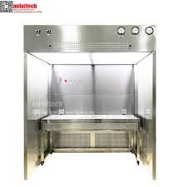

Dispensing booth

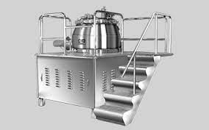 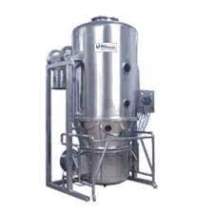

Rapid mixer granulation fluid bactch dryer

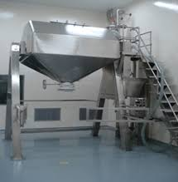 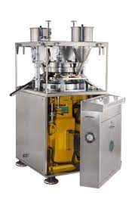

Octoganal blender compression machie

Defects in Tablets

1. Capping

In this there is partial or complete removal of top and bottom portion of tablets

* Reasons

1. Excessive fine
2. Defective punch die
3. Granules too dried

* Defect can be removed

1. Setting the die and punch properly
2. Reduce % of fine
3. Punches should be polished
4. Maintain the speed at optimum & regulate the pressure of punches
5. Weight variation

Weight variation occur during the compression of granules in a tablet machine and the tablet do not have the uniform weights

* Reasons

1. Granules are not in uniform size
2. Presence of excess amount of powder in granules
3. During compression change in capacity of die
4. Variation in the speed of tablet machine
5. Hardness Variation

* The tablets do not have uniform hardness
* It depends on the weight of the material and space between the upper and lower punch during the stage of compression
* If the volume of the material varies and distance varies between punches, hardness also varies

Evaluation of Tablets

Official test

Unofficial test

Official Test

1. Size and shape and appearance of tablet

* The general appearance of tablet, its identity and general elegance is essential for consumer acceptance, for control of lot to lot uniformity and tablet-to-tablet uniformity. The control of general appearance involves the measurement of size, shape, color, presence or absence of odor, taste etc.
* Size and shape can be dimensionally described and controlled. The thicknesd of tablet is only variables. Tablet thickness can be measured by other device. Tablet thickness should be controlled within a 5% variation of standard value
* Unique identification marking utilize some form of embossing, engraving or printing. These markings include company name or symbol, product code, product name etc..

1. Content of active ingredient

* Perform assay of 20 tablets as per monograph
* The result should lie within the range for content of active ingredient stated in the monograph
* If small number of tablets are used then the limits specified in monograph ma be released to extent indicated in tablets

1. Uniformity of weight

* Weigh 20 tablets selected at random and determine their average weight. Not more than 2 of the individual weights may deviate from the average weight by more than the percentage deviation given in the table and none should deviate by more than twice that percentage

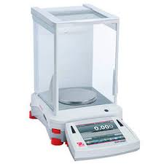

Weighing machine

1. Uniformity of content

* It is used to ensure that every tablet contains the amount of drug substance intended with little variation

Procedure

* 10 tablets are assayed
* 9 tablets should have % limit of 85-115%
* If more than 1 tablet deviates from 85-115%
* 20 tablets are assayed
* Not more than 1 tablet should have the % limit of 75-125%

1. Disintegration test

* Disintegration of a tablet means to break a tablet into smaller particle after swallowing. The time required to disintegrate the tablet is called disintegration time
* The tablets are kept immersed in the liquid within the tubes by means of cylindrical guided discs. The assembly is suspended in the liquid medium in a 1000ml beaker. The apparatus is operated generally for 15 minutes and observed for disintegration of tablets
* The tablets pass the test if all tablets disintegrate. In case one or two tablets fail to disintegrate, repeat the test on 12 additional tablets. The tablets pass the test if not less than 16 of the 18 tablets tested have disintegrated.

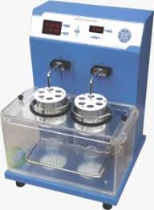

Disintegration test

1. Dissolution test

* It is the solubilization of the drug or active moiety in to dissolution media
* It is done for the measuring the amount of time required for a given percentage of the drug substance in a tablet to go into solution under specified condition.

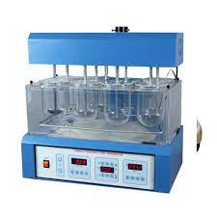

Dissolution test

Unofficial Test

1. Hardness test :

* It is defined as the force required to break a tablet in a diametric compression test. Tablet requires a certain amount of strength or hardness and resistance to friability to withstand mechanical shocks of handling in manufacture, packingand shipping

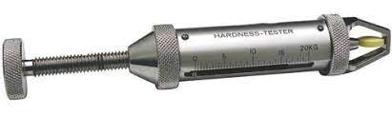

Hardness tester

1. Friability test

* It is performed to evaluate ability of the tablet to with stand wear and tear in packing , handling, and transporting
* The apparatus used to perform this test known as Friabilator
* The apparatus consist of plastic chamber, which is divided into two parts and it revolve at speed of 25rpm
* Twenty tablets are weighed and placed in a plastic chamber is roated for 4 minutes or 100 revolutions
* During each revolution the tablet falls from a distance of 6 inch
* The tablets ate removed from the chamber after 100 revolution and weighed. Loss in weight indicates the friability. The tablets are considered to be good quality if the loss in weight is less than 0.8%

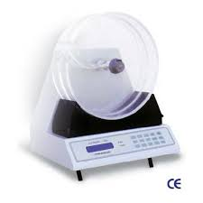

Coating of Tablets

A tablet coating is a process of covering over a tablet which is used to mask the taste make it easier to swallow or protect the active medication inside .

Purpose of coating

* Protects against light , air and moisture
* Protecting API against digestive fluids
* Better identification of tablet
* Avoid side effects
* Provides a delayed release of medication

Types of coating

* 1. Sugar coating
  2. Film coating
  3. Enteric coating

1.Sugar coating

* This involves application of sugar based coating solution to the tablets
* It is carried out in coating pans having variable capacities and mounted at an angle of 40
* degree
* The coating is water soluble and dissolves after swallowing

2.Film coating

* This technique is more used as compared to sugar coating
* In this process there is deposition of a thin film of polymer surrounding the tablet core
* The film formed is very thin and it gives the tablet a less weight and small size
* Example :HPMC (Hydroxy propyl methyl cellulose) , EC (Ethyl cellulose) , HPC (Hydroxy propyl cellulose)

3.Enteric coating

* Enteric coating tablets have delayed release features
* They are designed to pass unchanged through the stomach to the intestine where the
* tablets disintegrates and allow drug dissolution and absorption.
* Example : omeprazole , aspirin etc

Coating machines

1. Standard coating pan

* Standard coating pan consists of a circular metal pan mounted somewhat angularly on the stand.
* The pan is 8 to 60 inches (15 and 200 cm) in diameter and is rotated on its horizontal axis by a motor.
* The rotational movement of the pan causes the batch of tablets loaded into the pan to tumble and make multiple passes through the spray application zone.
* Coating solution is applied to the rotating tablet bed by spraying in atomized form which can produce a faster and more even distribution of solution than simply introducing it as a liquid.
* Heat air is directed into the pan and onto the tablet bed surface and is exhausted by means of the ducts positioned through the front of the pan.
* In order to achieve significant drying efficiency, a number of modifications were made to the design of the hot air handling equipment of standard coating pan.

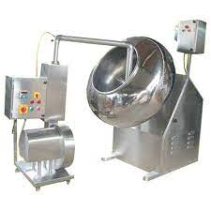

Standard coating machine

1. The perforated pan systems

* Perforated coating pan consists of a perforated or partially perforated drum that is rotated on its horizontal axis in an enclosed housing.
* The coating solution is applied to the surface of the rotating bed of the tablets through spraying nozzles that are positioned inside the drum.
* Perforated pans became popular when pharmaceutical manufacturers switched from organic solvent-based coatings to aqueous coatings.
* The switch was a natural response to the volatility of organic solvents; the high cost of explosion-proof installations, which became necessary in the 1980s to account for that volatility; and the introduction of the Clean Air Act and its amendments in the early 1990s.
* Perforated coating pans come in various designs depending on the vendor, but the intention is to maximize the drying capability of the machine so as to minimize core penetration at high spray rates.

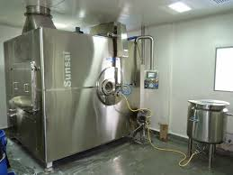

Perforated pan system

3. Fluidized bed or air suspension systems

* Fluidized-bed coating equipment or air suspension coaters are highly efficient coating systems in which the coating solution is sprayed on to tablets that have been suspended in a columnar chamber by a positive airflow.
* The airflow is controlled so that more air enters the center of the column, causing the tablet to rise in the center.
* The tablets in the center move upwards in the airflow and fall outwards and downwards to the chamber wall, at which stage the process is continuously repeated from the bottom part of the column.
* Coating solutions are continuously applied from the spray nozzles located at the bottom of the chamber or sprayed onto the top of the cascading tablet bed by nozzles located in the upper region of the chamber.
* Tablet cores that are friable and prone to chipping and edge abrasion may be difficult to coat even under the optimum conditions in the fluidized bed systems, owing to the relatively rough tablet to tablet impact and tablet chamber contact.

Advantages of tablet coating machines

* Faster and more even distribution of coating solutions or suspensions can be achieved when atomizing system is used.
* Spraying can reduce the drying time between solution applications in sugar coating and allows for continuous application of solution in film coating.
* It is applicable for both sugar and film coating processes.
* Perforated pans, by design, tend to be more efficient users of energy.
* The design of the coating machine increases the drying efficiency, which results in shorter coating times.
* Several airflow configurations are possible in Glatt coater.
* It can be used for both sugar and film coating processes.
* The ability of air suspension coaters to simultaneously to suspend and coat tablets leads to high coating efficiency.
* It offers an alternative to pan coating and is particularly popular for coating multi particulate

Quality Assurance

Quality assurance are action taken to design and manufacture a safe and effective product by building quality controls into the product life cycle. A quality assurance is responsible for ensuring that products and services meet the established standards set by the company. Duties include maintaining strong overall quality control of products made by the company adhering to reliability, performance and customer expectation. Inspection of products is part of the job with the obligation to report and document findings

Role of quality assurance

Ensure drug work safely and as intended

Responsibilities

* Create quality measurements to track improvement in products
* Execute quality improvement testing and activities
* Develop quality assurance standards and company processes
* Adhere to industry quality and safety standards
* Ensure products meet customer expectations and demand
* Create reports documenting errors and issues for fixing
* Work closely with the development team to improve existing products
* Maintain standards for reliability and performance of production

Functions

* Warehousing of incoming components, containers and closures, labels etc.
* Manufacturing process and process checks.
* Process monitoring and Process controls.
* Production Record Review.
* Final release or rejection of every batch of Drug Products for distribution and sale.
* Stability testing and evaluation of shelf life of products
* Wearhousing of finished products
* Complaints and product recall
* Handling of changed control system
* Out of specification investigation
* Investigation of deviation
* Returned products
* Control of non confirming products
* Reprocessing of contolling products

Procedure

*Equipment coding:

The engineers communicate with the user for receipt of equipment and sends to QA to allot the number, which contains six characters.

Example: XX-YYY indicates department code and three digit number respectively.

*Procedure for monitoring Temperature and Relative humidity:

Carried out by hygrometer and air conditioning systems.

*Differential pressure monitoring:

Carried out in a closed area.

*Verification and calibration of balance:

Daily based and monthly based calibrations.

*Maintenance of standard weight annual certification and stamping by weights and measures:

Standard weights to be sent for authorization and maintained.

*Line clearance:

Defined assequential checks which are to be performed before starting any processing

activity.

*Sampling of intermediate and finished product:

Sampling quantities for intermediate and finished product, bulk product labels and

container labels.

*Storage and retrieval of documents:

Responsible for all types of documents.

*Password policy for software in laboratory and GMP systems:

Maintaining the passwords for different analysis process as per good manufacturing

process.

*Good documentation process:

Entries and corrections of documents.

*Handling and issuance of cleaning agent:

Cleaning of glasswares and manufacturing equipments and parts.

*Temperature mapping:

Documented measurement of temperature and relative humidity with in the storage area.

*Training of contract employees:

Carried out with cGMPs.

*Computer system validation policy:

Following strategies and quality standards by computerized systems.

Types

* 1. Documental QA
  2. IP QA
  3. Data Conversion Testing QA
  4. Regression QA
  5. Mobile Testing QA

1. Documental QA:

An internal document to organise, plan, and implement the activities

1. Identity Preserved QA:

The maintenance of products specific traits through growing, production and

marketing channel

1. Data conversion testing QA:

It is done to verify conversion of one data format to another data format that can

be used continuously by a application under test process.

1. Regression testing QA:

Testing the software after a development cycle to ensure that existing

functionalities haven't been adversely affected.

1. Mobile testing QA:

Is a process by which application software developed for handheld mobile

devices is tested for its functionality, usability and consistency

Quality Control

* Quality control is a process of setting standards and testing to make sure something, like a product or service, is done correctly.
* These help ensure that the necessary and relevant tests are executed and that materials are not released for use, nor products released for sale or supply, until their quality has been confirmed to comply with international standards.

Quality Control Unit (QC)

It consists of various quality control instruments.,

* UV spectroscopy
* Dissolution tester
* pH meter
* stability chamber
* cooling chamber and deep freezer
* HPLC
* Gas chromatography

UV Spectroscopy

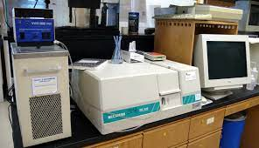

It is an absorption spectroscopy in part of UV and adjacent visible spectral regions. It is used to view the absorption of the sample invisible and adjacent ranges .It indicates the presence of analyte gives the response assumed to proportional to concentration and identifies the contaminants with in the substance or measures the kinetics of the reaction.

Dissolution tester



It determines the action of tablet in the different time intervals with the d ifferent serial numbers. There are three typical situations where dissolution testing plays a vital role:

* + 1. Formulation and optimization decisions: during product development, for products where dissolution performance is a critical quality attribute ,both the product formulation and the manufacturing process are optimized based on achieving specific dissolution targets.
    2. Equivalence decisions :during generic product development ,and also when implementing post- approval process or formulation changes, similarity of invitro dissolution profiles between the reference product and its generic or modified version are one of the key requirements for regulatory approval decision
    3. Product compliance and release decisions: during routine manufacturing, dissolution out comes are very often one of the criteria used to make product release decisions.

Ph meter

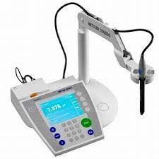

A pH meter provides a value as to how acidic or alkaline a liquids. The basic principle of the pH meter is to measure the concentration of hydrogen ions. Acids dissolve in water forming positively charged hydrogen ions(H+).The greater this concentration of hydrogen ions, the stronger the acids. Similarly alkali or bases dissolve in water forming negatively charged hydrogen ions(OH-).The stronger a base is the higher the concentration of negatively charged hydrogen ions there are. The amount of these hydrogen ions present solution is dissolved in some amount of water determines the pH. A pH value of indicates a neutral solution. Pure water should have a pH value of 7. Now pH values less than 7 indicate an acidic solution while a pH value greater than 7 will indicate an alkaline solution. A solution with pH value of 1 I is highly acidic and a solution of pH value of 14 is highly alkaline.

Stability chamber

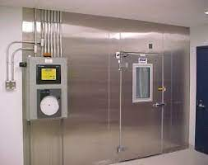

It comprises of carrying out the chemical analysis which are hazardous. It consists of vacuum oven with the muffle furnace with stands more heat during the time of operation .According to the laws of Physics ,the more the chamber`s temperature ,the higher is the capability of the air to retain moisture at that particular temperature .Relative humidity(RH) may be defined as the ratio of the amount of moisture present in the air to the amount of moisture that the air is capable of holding. This translates to the fact, that relative humidity gets proportionally altered with a simultaneous alteration in the ambient temperature. A stability chamber`s working principle is based on its ability to maintain a stable temperature ,and thus ,maintain a stable value of relative humidity. Our reliable stability chambers are appropriate for storing biological specimens and cytological samples ,and for testing 20 the acceleration or deceleration in the half lives of pharmacologically active substances.

Cooling chamber and deep freezer

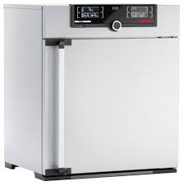

Here the temperature maintained is about 2 to 8 degree Celsius and in the deep freezer is about 2 degree Celsius. I the lp sin maintaining the safe temperature control of medicines and drugs and also helps in the storage and availability of drugs

HPLC

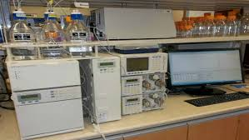

It is based on the adsorption principle consists of mobile phase off our channels A .mobile phase B. mobile phase for gradient use C .highly organic(80:20) D.highly aqueous(20:80) The water washing is done with20./.methanol. The parts includes, detector ,column oven or compartments, sample compartment and mobile phase. The principle of separation in normal phase mode and reverse phase mode is adsorption. When a mixture of components are introduced into a HPLC column, they travel according to the irrelative affinities towards the stationary phase .The component which has more affinity towards the adsorbent, travels lower. The component which has less affinity towards the stationary phase travel sfaster. Since no2 components have the same affinity towards the stationary phase ,the components are separated. It helps in the identification, quantification and purification of the samples

MICROBIOLOGICALUNIT

* In this unit ,the water analysis carried out identified with any growth of new microorganisms and process is done accordingly.
* The preparation of the required media for the specific organism is done often to check out their activity.
* It consisted of two horizontal LAFs laminar air flows to carry out the inoculation process and a Hot air oven (57-63degrees).
* It also consisted of BOD incubators (20-25degrees), CO2 incubators and normal incubators where in the growth of microorganisms is examined properly at different temperatures which varied from low to very high.
* It consisted of the autoclave which was operated for 30 min for 30lbs pressure.
* The analysis of the new microorganisms in the water samples present within the industry and checking for the effect the microorganism have on the drugs

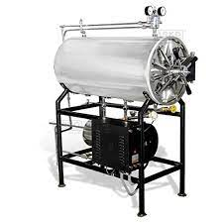 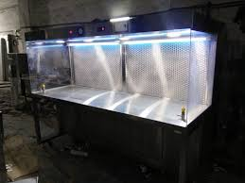

Horizontal autoclave Laminar airflow

Packing

* Packing is the science ,art and technology of enclosing and protecting of products for distribution , storage , sales and use
* Packing also refers to the process of design , evaluation and production of packages .

Characterisitcs of packing

* Protection from environment condition
* Non reactive with the product.
* Non toxic
* Not impart taste or ordor to the product

Types of packing

* PRIMARY PACKING

It is the material that first envelops the product and holds it

1. Blister Packing
2. Strip Packing

1. Blister packing

* Blister packs are usually used foe unit dose packing for tablets

The components of blister packing comprise of

* Forming film : a pocket inside which a tablet fits
* Backing : the lidding foil sticked over the back of the blister

Steps involved in blister packing

1. Thermoforming : this involves heat softening a sheet of thermoplastic resin and then
2. vaccum drawing the soften sheet of plastic into a mold. After cooling a sheet is
3. removed from mold.
4. Filling : the sheet is then proceed to the filling stations for filing
5. Sealing : sealing is then accomplished by liding it with a heat sealable backing material
6. Strip Packing

* A strip packing is formed by feeding two webs of heat sealable fixing through a

heated crimping rollers .

Steps involved in strip packing

* The product is fed into the pocket formed between two heat sealable fixable films
* Sealing is accomplished by heat crimping rollers
* The strip is then cut into desired number of packets in the length

Secondary packing

* It is the outside the primary packaging used to group primary packages together

Tertiary packing

* Used for bulk handling and shipping

Evaluation of packing material

1. Visualise inspection of surfaces
2. Leak test
3. Visualise inspection of surfaces

* Visual inspection aims to determine the absence or presence of visible particles within parenteral products

Factors considered during packing

* Indicate product ID and location.
* Capture photo evidence of products and/or defects.
* Determine pass/fail decisions based on a reference image.
* Identify visual defects based on defect criteria.
* Complete the visual inspection with a digital signature.

1. Leak Test

* Leak test plays an important part to secure sterility over the shelf life of a product and prevent microbiological, oxygen or moisture ingress into the primary packaging .
* A leak test is used to determine if an object, product, or system functions within a specified leak limit.
* The sealing of the packing should be checked properly where there is entry of water.

Storage

The manufacture goods should be stored in clean and dry and should be maintained within the acceptable temperature

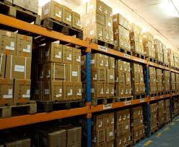

Storage area

Conclusion

The Indian Pharmaceutical company is the fastest growing industries in the world competing with global pharmaceutical industries. It is in the front rank of India’s science based industries in post independence era. The Indian pharmaceutical company was completely dominated by multinational companies and drug prices in India was among the highest in the world. It can be expected that after a year (or) more, we will see a good result being produced

References

1. Remidex Pharma Pvt.Ltd., Bangalore, company profile
2. <https://www.slideshare.net/sonusinternationa/what-are-the-types-of-pharmaceutical-raw-materials>
3. <https://www.slideshare.net/AvinashGowda37/tablet-manufacturing-process-133253074>
4. Anand, Om; Yu, LawrenceX.;Conner ,DaleP.;Davit,BarbaraM.(2011-04-09)."DissolutionTestingforGenericDrugs:AnFDA Perspective".TheAAPSJournal.13(3):328–335
5. Zhang,X.;Duan,J.;Kesisoglou,F.;Novakovic,J.;Amidon,G.L.;Jamei,M.;Lukacova,V.;Eissing,T.;Tsakalozou,E.(2018)."MechanisticOral Absorption Modeling and Simulation for Formulation Development and Bioequivalence Evaluation: Report of an FDA Public Workshop".CPT:Pharmacometrics&SystemsPharmacology.6(8): 492–495
6. Quality control SOP file
7. Microbiology unit micro labs
8. Packing SOP file